Introduction to Data Visualization

**Introduction to Data Visualization**

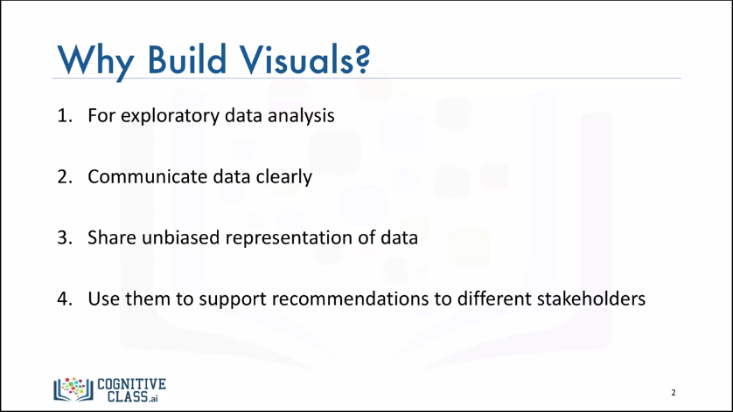

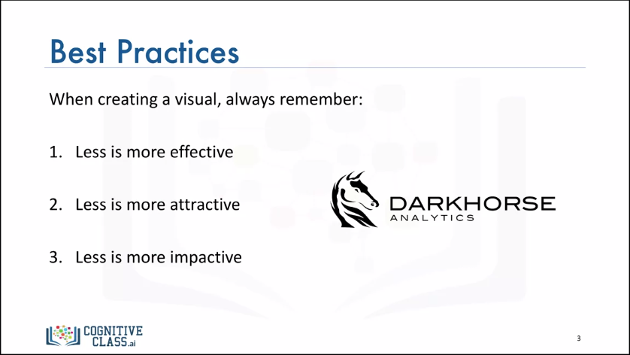

**Introduction to Matplotlib**

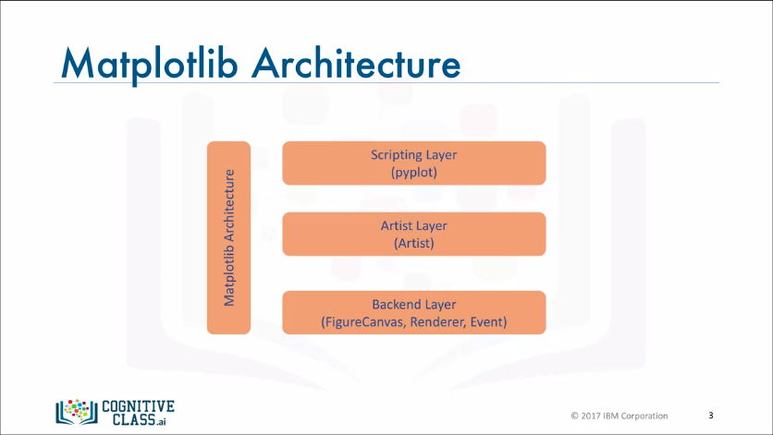

Matplotlib's architecture is composed of three main layers: the **back-end layer**, the **artist layer** where much of the heavy lifting happens and is usually the appropriate programming paradigm when writing a web application server, or a UI application, or perhaps a script to be shared with other developers, and the **scripting** **layer**, which is the appropriate layer for everyday purposes and is considered a lighter scripting interface to simplify common tasks and for a quick and easy generation of graphics and plots.

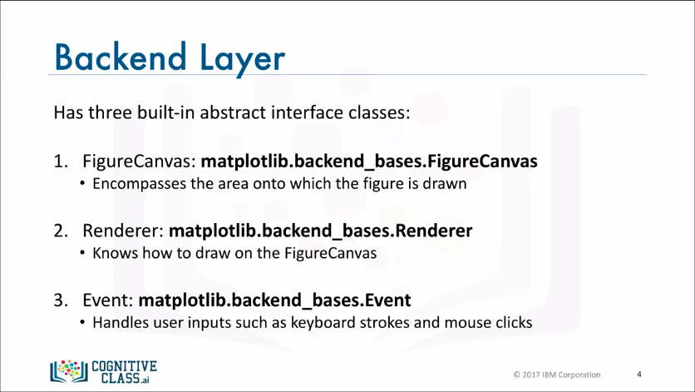

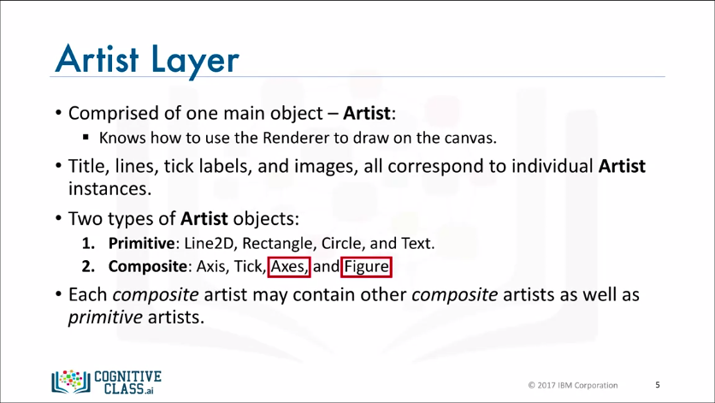

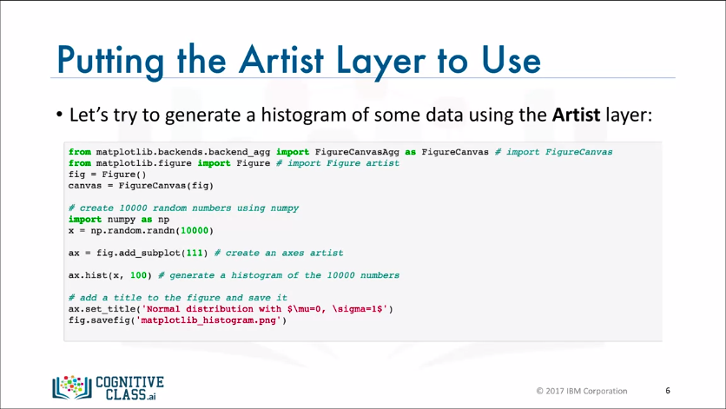

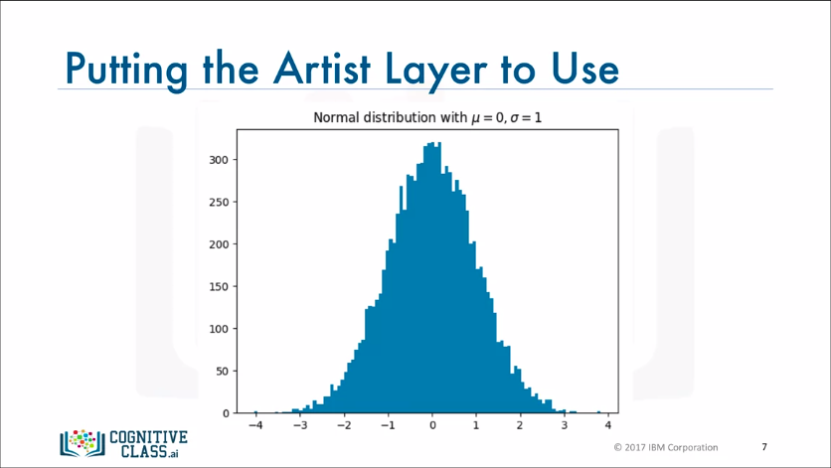

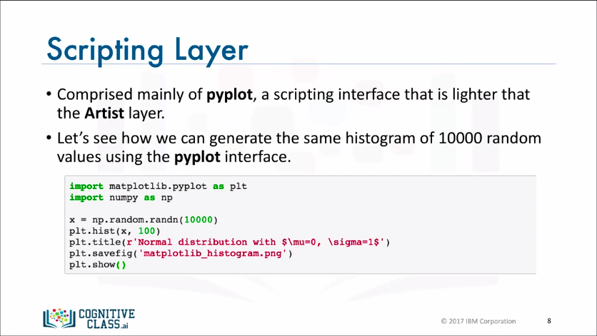

**Line Plots**

What is a line plot? As its name suggests, it is a plot in the form of a series of data points connected by straight line segments. It is one of the most basic type of chart and is common in many fields not just data science. The more important question is when to use line plots. The best use case for a line plot is when we have a continuous dataset and we’re interested in visualizing the data over a period of time.

